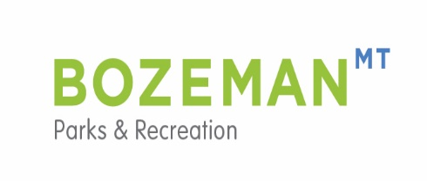
SWEET PEA CHILDREN’S RUN 2017
INFORMATION PAGE

Congratulations on entering the Sweet Pea Children’s Run. It will be lots of fun and very rewarding to run down the parade route with all of Bozeman cheering you on!
The run will be held on Saturday, August 5, beginning at 10:00a.m sharp. The staging area for the Children’s Run will be at 8th and Main. Main Street is closed to traffic at 9:30 a.m. and runners may begin lining up at that time. We ask parents to help us line the children up with the oldest in the front and the strollers in the back. For example the 12 year olds should be in front, followed by the 11, 10, 9 on down to 2 year olds, and then the strollers. Please pin the race number on the front of your child’s shirt. Adults are encouraged to run with any of the children but must accompany children under 7.
The finish of the race will be on South Church Street. Runners will be guided to turn to the right on to S. Church where tables with snacks and water will be set up for the children. Please establish a “meeting place” for you and your child immediately following the race. There will be a lot of people at the finish area and we want to make sure all children stay safe and find their parents. If children are not able to find their parents, we will keep them at the snack table located on south Church until you arrive .
If you would like to know your child’s run time please bring a stop watch or look at the finish line clock. We will only be timing the first 20 (or so) children to cross the finish line. The Parks and Recreation Department Staff will be taking pictures during the race for marketing purposes; if you would not like your child’s picture used in future Parks and Recreation Department marketing materials or in the newspaper, please call our office at 582-2290 and let us know. When you call we will ask you for your child’s race number.
The Bozeman Parks and Recreation Department is located in the Beall Park Recreation Center at 415 North Bozeman Avenue. The phone number is 582-2290. Please feel free to call with any questions.

Enjoy the race!

