**2017 Sweet Pea Children’s Run Registration Form –AUGUST 5**

Email

Age on Race Day: **8/5/17**

**Registration Fees**:

___$5 per child

T-shirts will be available for sale at the Beall Park Recreation Center June 19-August 4

Address

Phone

Date of Birth

Zip

State

City

Official Use Only (Race #)

Circle Sex **F**  **M**

Last Name

First Name

**Read this race participation agreement and release, then sign below. By signing this document you may be waiving your legal right to a jury trial to hold the provider legally responsible for any injuries or damages resulting from risks inherent in the sport or recreational opportunity or for any injuries or damages you may suffer due to the provider’s ordinary negligence that are a result of the provider’s failure to exercise reasonable care.**I know that participating in a road race is a potentially hazardous activity. I agree I should not enter the run/walk unless I am medically able and properly trained. I agree to abide by any decision of a race official relative to my ability to safely complete the event. I assume all risks associated with participating in this event including but not limited to falls, contact with other participants, the effects of the weather, including hypothermia, traffic and conditions of the road, all such risks being known and appreciated by me. Having read this waiver and knowing these facts, and in consideration of your accepting my entry, I, for myself and anyone entitled to act on my behalf, freely and voluntarily waive and release The City of Bozeman, The Sweet Pea Festival of the Arts, all sponsors, their officers, employees, agents, volunteers, and successors from all claims of liabilities of any kind arising out of my participation in the event, even though that liability may arise out of negligence, or carelessness on the part of persons named in this waiver. I grant permission to all the foregoing to use any photographs, motion pictures, recordings or any other records of this event for any legitimate purpose. No dogs or headphones are allowed. I have read and agree to abide by the conditions of this waiver.

________________________________________________________________________ __________________

Signature of Participant/Parent or Guardian if participant is under 18 years old Date

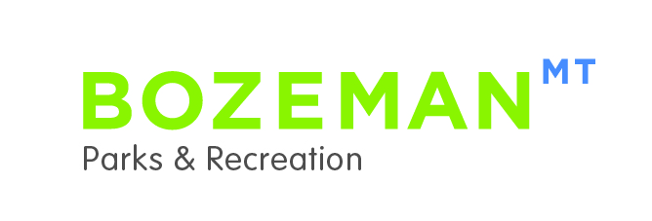

**Registration Dates and Locations:**

Registration must be done in person at the following locations.

**Beall Park Recreation Center (415 N. Bozeman Ave)**

**Monday-Friday, 8:30am -4:30pm** *(closed for lunch 12-1pm)*

**August 2-4**

**First Security Bank (670 S. 19th)**

**10:00am-5:30pm**

